Name Reyawna McElroy_____________________________
Date 2/8/11______________________________
TV Studio – Matching Activity

Please label each piece and what it does.

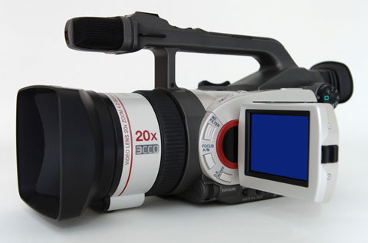
This is a video camera that records people and sound This is a hard drive
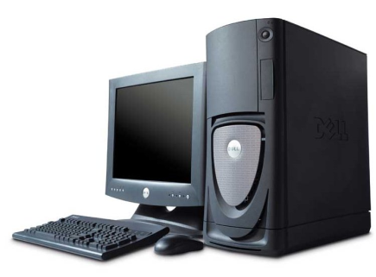
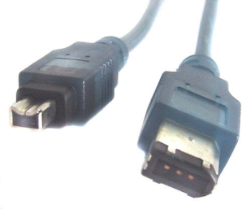
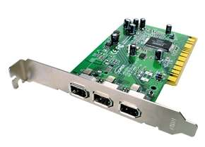

This is a fire wire cable used for video cameras This is a computer and a Desktop

